Software User Manual for Sample Pro

Startup Interface
After powering on the camera, wait approximately 20 seconds, then double-click SamplePro to launch the camera software. The software startup interface is shown in Figure 1-1. Wait for the loading process to complete. The startup time may vary depending on the capture card used (approximately 5 seconds for Euresys capture cards, and about 10 seconds for Samadhi capture cards).
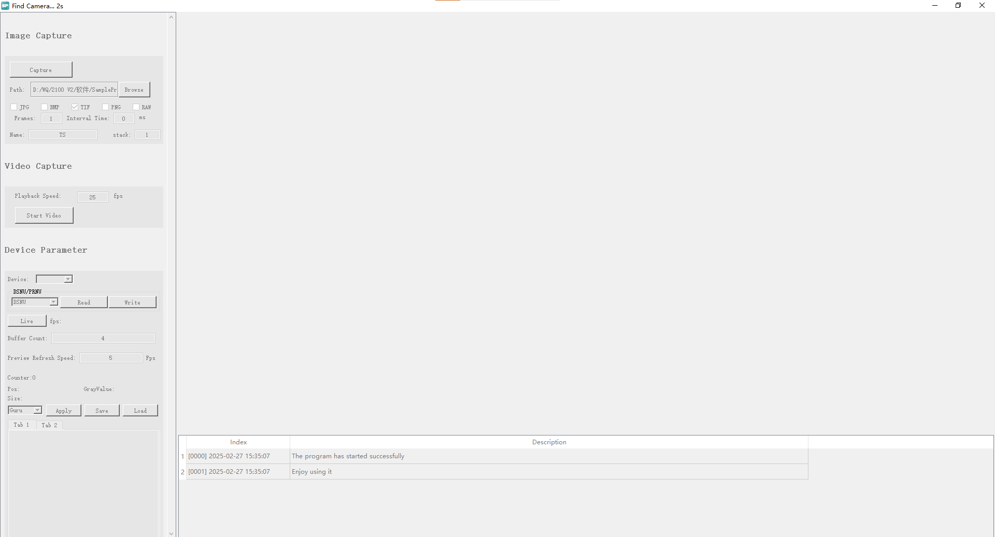
Figure 1-1

User Interface
The main interface of the SamplePro software consists of five sections: Preview Window, Software Window, Image Capture, Camera Control, and Image Adjustment, as shown in Figure 2-1.
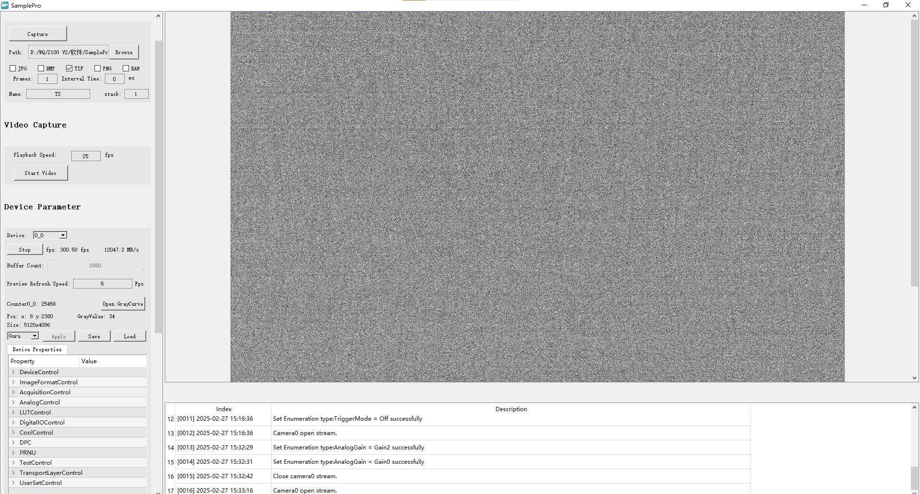
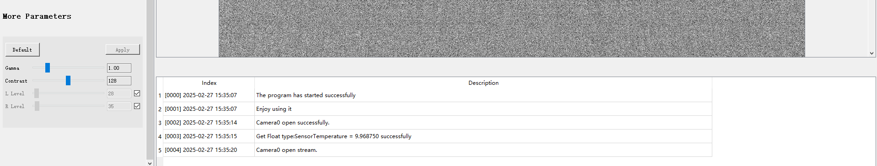
Figure 2-1

Preview Window
The preview window displays the real-time image captured by the camera under the Stream module. It supports real-time zooming—users can zoom in or out of the preview image using the mouse scroll wheel according to their needs.
On the left side of the preview window, information such as the pixel gray value, coordinates of the mouse position, and the image resolution are displayed in real time, as shown in Figure 2-2.
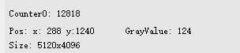
Figure 2-2

Software Window
The software window includes the common functions of “Minimize,” “Maximize/Restore Down,” and “Close,” as shown by the corresponding icons on the top right of the interface.

Image Capture
The Image Capture module provides the camera’s basic functions for taking photos and recording videos. Users can select different image formats for snapshot capture or set a custom duration for video recording according to their needs. By default, all captured images and videos are saved in the img folder under the software’s root directory.

Camera Control
The main camera functions are located in this module. Users can expand and operate the corresponding function panels as needed for their specific applications.

Image Adjustment
In the Image Adjustment interface, users can fine-tune the gamma and contrast values, and set the left and right levels according to the difference between the real-time preview and the actual sample, in order to achieve the desired image effect.

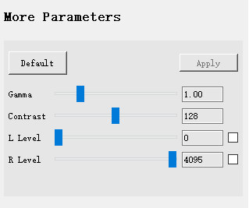
图 2-3

Image Capture
As shown in Figure 3-1, the Image Capture module supports the camera’s basic functions for taking photos and recording videos.
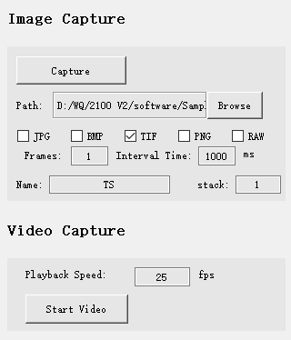
Figure 3-1
- Capture: Click this button to take a photo.
- Path: Defines the save path for captured images and videos. Click Browse to customize the storage path.
- Format: Select the image format. Supported formats include JPG, BMP, TIF, PNG, and RAW. The default format is TIF, and multiple formats can be selected simultaneously.
- Frames: Sets the number of images to be captured. The default is 1 frame.
- Interval Time: Sets the time interval between captures. The default is 1000 ms.
- Name: Specifies the image file name. Custom naming is supported, with “TS” as the default prefix.
- Stack: Available when saving images in TIF format. The default value is 1; if set to a value other than 1, a Multi-Page TIF (MPTIF) file will be generated.
- Playback Speed: Sets the playback frame rate for videos. The default is 25 fps.
- Start Video: Manually start video recording.
- Stop Video: Manually stop video recording.

Camera Control
The main camera functions are managed in this module, including the control of image output modes, as shown in Figure 4-2.

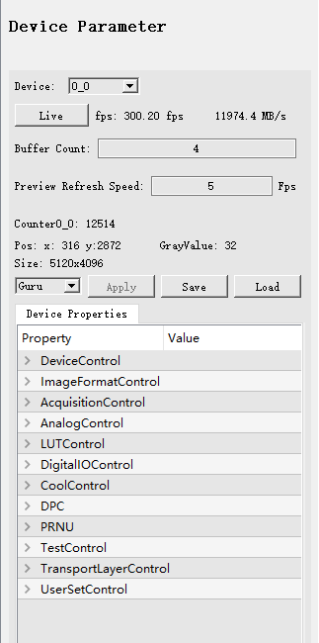
Figure 4-2
- Stop：相机处于流模式，预览窗口实时出图，外触发模式下，根据触发信号出图；
- Live：相机正常工作，不出图；
- Buffer Counter：存内存缓存帧数量申请，需大量存图时推荐设置总内存大小的70%；
- Preview Refresh Speed：实时数据流预览帧率设置，当不关注图像内容时可设置0关闭预览显示，最大预览帧率不超过相机实时帧率；
- fps：显示相机实时帧率；
- ：显示相机实时流量；
- Counter：统一预览出流帧数量；
- 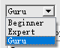：操作者模式选择，分为Beginner、Expert、Guru，使用相机所有功能请选择Guru模式。
- Stop: When the camera is in Stream Mode, the preview window displays live images. In External Trigger Mode, image output is controlled by the external trigger signal.
- Live: The camera is powered on but not outputting images.
- Buffer Counter: Defines the number of frames allocated to the memory buffer. When capturing a large number of images, it is recommended to set this to about 70% of the total available memory.
- Preview Refresh Speed: Sets the frame rate for the live preview. If real-time image display is not needed, set this value to 0 to disable preview output. The maximum preview frame rate cannot exceed the camera’s real-time frame rate.
- fps: Displays the camera’s real-time frame rate.
- : Shows the camera’s real-time data throughput.
- Counter: Displays the total number of frames output in the current preview stream.
- : Select the user access mode — Beginner, Expert, or Guru. To access all camera features, select Guru mode.

Device Control
This section displays the camera’s basic information (read-only), allows UserID editing, camera reset, and shows the real-time Device temperature, Sensor Board temperature, Sensor temperature, and timestamp information, as shown in Figure 4-3.

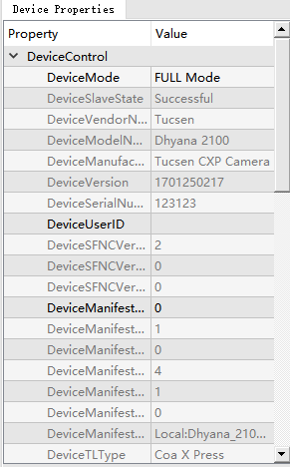
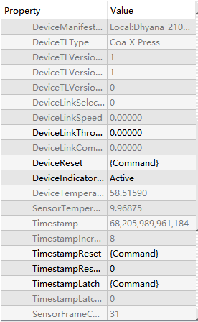
Figure 4-3
- DeviceMode: Switches between single and dual acquisition card channels. Select Base Mode when using a single acquisition card, and Full Mode when using dual acquisition cards.
- DeviceUserID: Allows users to edit and customize the Device User ID. Supports alphanumeric input in both Chinese and English.
- DeviceReset: Resets the device without powering it off. The camera will automatically reload the default parameter configuration.
- DeviceTemperature: Displays the real-time temperature of the device (read-only).
- SensorTemperature: Displays the real-time temperature of the sensor (read-only).
- Timestamp: Shows the timestamp information with a precision of 8 ns (read-only).
- TimestampReset: Resets the timestamp counter, restarting time measurement from the current captured frame.
- TimestampLatch: Captures the current timestamp information.
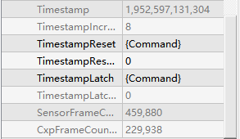
图4-5
- SensorFrameCounter：Displays the current sensor frame count, indicating the total amount of data output.
- CxpFrameCounter：Displays the frame count from the CXP interface. When the camera is operating in dual-camera mode, the CXP count will be half of the sensor count.
Note: When operating at a very high frame rate, some frames may be output from the sensor after the CXP interface has stopped counting, resulting in a few lost frames.

ImageFormatControl
This section allows users to set the camera resolution, ROI, Binning mode, horizontal and vertical mirroring, pixel bit depth, and test image, as shown in Figure 4-6.
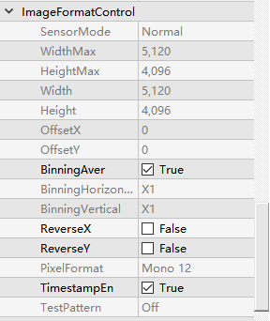
Figure 4-6
- SensorMode: The sensor supports two modes: Normal and Fast Binning. In Fast Binning mode, both the frame rate and the signal-to-noise ratio (SNR) are improved (only 12-bit mode supports Fast Binning).
- WidthMax: Displays the maximum horizontal resolution of the current image (read-only, shown in gray).
- HeightMax: Displays the maximum vertical resolution of the current image (read-only, shown in gray).
- Note: In Normal mode, the resolution is 5120 × 4096; in Fast Binning mode, it is 2560 × 2016.
- Width: Sets the horizontal image width. The minimum value is 128, with a step size of 32.
- Height: Sets the vertical image height. The minimum value is 1, with a step size of 1.
- OffsetX: Sets the horizontal starting position of the image. The minimum value is 0, with a step size of 1.
- OffsetY: Displays the vertical starting position of the image (read-only, shown in gray). The FPGA automatically centers the ROI based on the selected height to improve the frame rate.
- Example: In Normal mode, when Height = 2048, OffsetY = 1024.
- BinningAver: Switches the binning calculation mode. When checked, the camera uses average binning; when unchecked, it uses sum binning.
- BinningHorizontal: Selects the horizontal binning factor — supports ×1, ×2, ×4, and ×8.
- BinningVertical: Selects the vertical binning factor — supports ×1, ×2, ×4, and ×8.
- ReverseX: Enables horizontal mirroring. When checked, the image is flipped horizontally.
- ReverseY: Enables vertical mirroring. When checked, the image is flipped vertically.
- PixelFormat: Selects the pixel bit depth. Supported formats are 8-bit, 10-bit, and 12-bit.
- TimestampEn: Enables or disables the timestamp display. When enabled, the timestamp is embedded in the first 1–14 pixels of the top-left corner of the image, encoding information such as the current frame’s timestamp, frame count, readout start time, and exposure start time (see the attached document for detailed explanation).
- TestPattern：The sensor’s raw data output supports several test patterns, including horizontal grayscale gradient, diagonal grayscale gradient, moving diagonal grayscale gradient, and sensor test image.

AcquisitionControl
This section allows users to set the camera frame rate, trigger mode, and exposure mode, as shown in Figure 4-8.
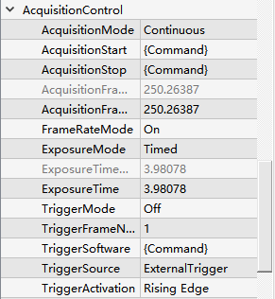
Figure 4-8
- AcquisitionStart: In Stream Mode, resumes image output and counting after a pause.
- AcquisitionStop: In Stream Mode, pauses the current software image output and stops counting.
- AcquisitionFrameRateMax: Displays the maximum frame rate the camera can achieve under the current settings (read-only, shown in gray).
- AcquisitionFrameRate: Sets the current camera frame rate. The minimum value is 0.095 Hz.
- FrameRateMode: When On, the frame rate setting takes priority. The maximum exposure time is limited by 0.95 ÷ frame rate (s). When Off, exposure time takes priority, and the maximum frame rate is limited by 0.95 ÷ exposure time (s).
- ExposureMode：Selects the exposure mode:
Timed: Manual exposure time set via interface parameters.
Auto: Automatic exposure mode (maximum auto exposure time 50 ms).
PulseWidth: Exposure time is determined by the high-level duration of the external trigger signal.
Note:
PulseWidth is available only when TriggerMode is On.
External trigger mode does not support auto exposure. Switching to auto exposure in external trigger mode will trigger internal image output.
- ExposureTimeMax:Displays the maximum exposure time available under current settings (read-only, shown in gray).
- ExposureTime: Sets the current exposure time in ms. Manual exposure range: 4 µs – 10 s; Auto exposure range: 4 µs – 50 ms.
- TriggerMode: Enables external trigger when On. Exposure mode can be set to PulseWidth.
Note: In Full Mode (dual acquisition card), the number of external triggers must be a multiple of 2.
- TriggerFrameNum：Sets how many frames are captured per external or software trigger pulse.
Example: Camera max frame rate = 100 Hz, external pulse frequency = 50 Hz, number of pulses = 100, TriggerFrameNum = 2 → the camera frame rate doubles to 100 Hz during the trigger, outputting 200 frames.
Note: In external trigger mode, it is recommended to use the default TriggerFrameNum = 1. Values >1 may cause frame loss.
- TriggerSoftware: Software trigger. Click the button to initiate image capture.
- TriggerSource: Selects the trigger source: ExternalTrigger or SoftTrigger. When TriggerMode is On, users can choose based on their needs.
- TriggerActivation: Sets trigger polarity. Options include Rising Edge, Falling Edge, or Any Edge.
Note:Any Edge is not supported when ExposureMode is PulseWidth. In dual acquisition card mode, the number of triggers must be even; an odd number may cause frame loss.

AnalogControl
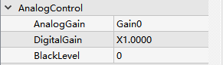
Figure 4-9
- AnalogGain: Sets the analog gain, supporting Gain0, Gain1, Gain2, and Gain3.
- DigitalGain: Sets the digital gain, adjustable from ×1 to ×15.5.
- BlackLevel: Adjusts the black level, increasing or decreasing the image’s baseline gray value. For 8-bit mode, the range is -255 to 255; for 10-bit and 12-bit modes, the values are scaled proportionally.

LUTControl
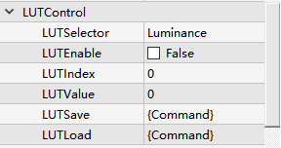
Figure 4-10
- LUTEnable: Toggle switch for LUT (Look-Up Table) control. Default is off.
- LUTIndex: Input value. After entering, the corresponding output value of the applied LUT curve is automatically loaded. Range: 0–4095.
- LUTValue: Output value corresponding to the entered LUTIndex. Can be manually modified and saved. Range: 0–4095.
- LUTSave: Saves the modified LUT curve.
- LUTLoad: Loads the LUT curve previously written to the application.
Note: Before using the LUT function, users must open the UpdateFW software to configure and write the LUT according to actual usage requirements.
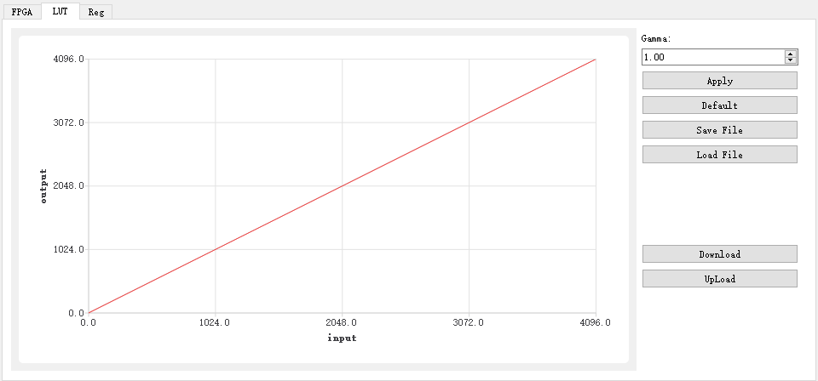
图4-11
- Gamma: Enter a value to display the corresponding INPUT–OUTPUT curve.
- Apply: Apply the currently selected LUT curve.
- Default: Restore the LUT curve to the default state when Gamma = 1.
- Save File: Save the current LUT curve to a specified file path.
- Load File: Load a previously saved LUT curve file.
- DownLoad: Upload the currently applied LUT curve configuration to the camera.
- UpLoad: Download and read the LUT curve from the camera (requires that the LUT curve has been previously saved in SamplePro).
The application steps are as follows:
Enter the desired Gamma value.
Click Apply to apply the currently selected curve.
Click DownLoad to configure the curve into the camera.

DigitalIOControl
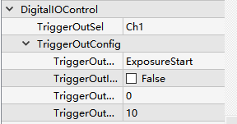
Figure 4-12
- TriggerOutSel: Selects one of the two output channels, Ch0 or Ch1.
- TriggerOutMode: Sets the output signal type for the selected channel (Ch0 or Ch1). Both channels support ExposureStart (signal at the start of exposure) and ReadEnd (signal at the end of readout).
- TriggerOutInverter: Enables high/low level inversion to invert the output signal.
- TriggerOutDelay: Sets the delay of the output signal relative to the exposure start. Adjustable range: 0–10000 µs.
- TriggerOutDuration: Sets the high-level duration of the output signal. Adjustable range: 0–10000 µs.

CoolControl
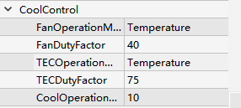
图4-13
- FanOperationMode: Fan operation mode. Options include Off (fan off), On (fan on), and Temperature (constant temperature mode).
- FanDutyFactor: Fan speed level, adjustable from 20% to 100%.
- TECOperationMode: TEC (Thermoelectric Cooler) operation mode. Options include Off (TEC off), On (TEC on), and Temperature (constant temperature mode).
- TECDutyFactor: TEC power level, adjustable from 0% to 100%.
- CoolOperationTemperature: Target cooling temperature, adjustable from -30°C to 50°C. Default is 10°C.

DPC
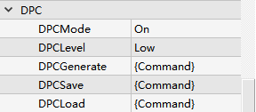
图4-14
- DPCMode: Enables or disables Defective Pixel Correction (DPC). Options: Off or On.
- DPCLevel: Sets the DPC correction level. Only Low is supported.
- DPCGenerate: Performs DPC calibration under dark-field conditions with long exposure.
- DPCSave: Saves the results of the DPCGenerate calibration.
- DPCLoad: Loads a previously saved defective pixel correction result.

PRNU
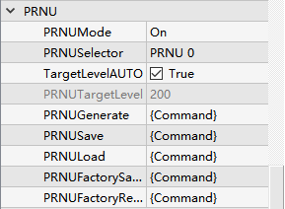
图4-15
- PRNUMode: Enables or disables PRNU (Photo Response Non-Uniformity) correction. Off disables PRNU; On enables PRNU.
- PRNUSelector: Selects the PRNU data set, supporting PRNU0 to PRNU5 (6 sets in total).
- TargeLevelAUTO: Automatic PRNU mode. The system automatically calculates the mean brightness of the current image. When checked, under uniform bright-field illumination, click PRNUGenerate to automatically generate PRNU correction data.
- PRNUTargetLevel: Manual PRNU mode. When automatic PRNU mode is unchecked, adjust the uniform bright-field brightness to the specified PRNU gray value, then click PRNUGenerate to generate PRNU correction data.
Example: Set PRNUTargetLevel to 128. Adjust the uniform bright-field to roughly half-saturation, then perform online PRNU calibration with one click.
- PRNUGenerate: Click to perform online PRNU calibration.
- PRNUSave: Save the current PRNU result to the selected PRNU set (PRNU0 to PRNU7).
- PRNULoad: Load previously saved PRNU data from the selected PRNU set (PRNU0 to PRNU7).
- PRNUFactoryReset: Restore the selected PRNU set (PRNU0 to PRNU7) to its factory default backup.
Note: When switching between different bit depths, the corresponding PRNUSelector must be used. PRNU background varies with bit depth, and using a mismatched PRNU background can cause image abnormalities.
Example: If the current PRNUSelector is set to PRNU0 and the image parameters are set to FastBinning–12bit, the preview may display abnormal images. This is because the resolutions of Normal and Fast Binning modes differ, making the PRNU background incompatible.
PRNUSelector Correspondence:

PRNU0 | Normal-10bit-Gain0
PRNU1 | Normal-12bit-Gain0
 | FastBinning-12bit-Gain0
PRNU2 | Normal-10bit-Gain1
PRNU3 | Normal-12bit-Gain1
 | FastBinning-12bit-Gain1
PRNU4 | Normal-10bit-Gain2
PRNU5 | Normal-12bit-Gain2
 | FastBinning-12bit-Gain2
PRNU6 | Normal-10bit-Gain3
PRNU7 | Normal-12bit-Gain3
 | FastBinning-12bit-Gain3

CXP Switching
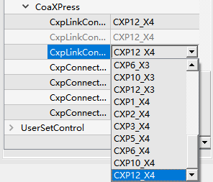
图4-16
- CxpLinkConfigurationPreferredSwitch: Selects the default CXP connection at startup.
- CxpLinkConfiguration: Switches the CXP mode. Default is CXP12_X4. Can only be changed when the camera is in Live mode; in Stop mode, the option is grayed out and cannot be changed.

UserSetControl
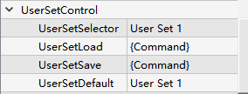
- UserSetSelector: Stores user configurations. Provides three options: Default, User Set1, and User Set2.
- UserSetLoad: Loads the selected configuration (Default, User Set1, or User Set2) into the camera.
- UserSetSave: Saves the current modified settings into the selected user set (User Set1 or User Set2).
- UserSetDefault: Defines the default user configuration loaded after a camera reset or power cycle. By default, User Set1 is loaded; after reset or power-off, the camera loads the parameters from User Set1.

